January 2009
Issue 8
Safety Matters


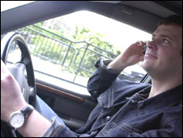
Articles:

• Driving Distractions and Speed Limits

• Accident Awareness

- Ladders

Tel: 020 7935 3013
Fax: 020 7935 3321
Email: enquiries@leia.co.uk
Welcome to the January 2009 edition of Safety Matters.
Through this newsletter our aim is to inform you of health and safety issues that may have an impact on the lift & escalator industry. Safety Matters is also available for download on the LEIA members website. www.leia.co.uk

Introduction

Driving Distractions and Vehicle Speeds

A staggering 85% of drivers have admitted that they don't know the legal speed limits when driving a van, with 36% confessing to breaking the speed limit on dual carriageways. Furthermore, according to a survey by Vauxhall looking at knowledge of speed limits for light commercial vehicles, most drivers believed that vans obey the same limits, whereas this only applies to vans with a Gross Vehicle Weight of less than 2,000kg.

The survey also revealed that 72% didn't know the correct speed on single carriageways; half believed it to be 40mph while the remainder thought it was 60mph. Dual carriageway limits for vehicles over 2 tonnes also proved to confound, with 28% thinking it was 50mph and 24% assuming it was 70mph, as opposed to the actual 60mph. There was also confusion over motorway speeds with only 44% listing it at 70mph - the other 56% thought it to be 60mph.

Drivers who kill while avoidably distracted at the wheel can now face jail.

Avoidable distractions include:
- Using a mobile phone (calling or texting)
- Drinking and eating
- Anything which takes the drivers attention off the road

Under the new sentencing guidelines, which courts are obliged to follow, drivers who cause death while using a handheld mobile phone will face up to seven years in prison. Drivers who cause death because they were momentarily distracted by a mobile phone can also expect a prison sentence.

www.sentencing-guidelines.gov.uk/docs/
Type of Vehicle | Built–up Areas | Single-carriage roads | Dual-carriage roads | Motorways
Cars (including car-derived vans up to 2 tonnes max laden weight) | 30 (48) | 60 (96) | 70 (112) | 70 (112)
Goods Vehicles (not exceeding 7.5 tonnes max laden weight)  e.g. Transit Van | 30 (48) | 50 (80) | 60 (96) | 70 (112)

Speed Limits MPH (Km/h)

Accident Awareness

As a result of this the engineer sustained a 25mm laceration to the back of the hand between the index finger and thumb. Treatment for the injury required four stitches.

DIRECT CAUSE

- Car doors not deburred.
- Lifting the Car Door into position with the strengthening strap.

CONTRIBUTORY CAUSES

- Sharp Edges
- Failure to identify the hazard

RECOMMENDATIONS
- Clarify and train where and when gloves are to be worn.

WHAT HAPPENED
Cuts from sharp edges are not uncommon within the lift and escalator industry. Sharp edges can often be found on doors and architraves as the following report illustrates.

During the re-fitting of a car door the engineer used the horizontal door strengthening strap as a handhold to raise the door into position. The strengthening strap gave way releasing the engineer’s grip which caused his hand to strike the door return edge.

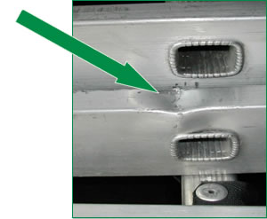
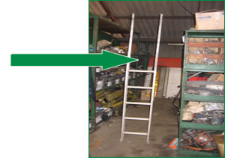
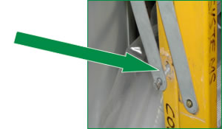
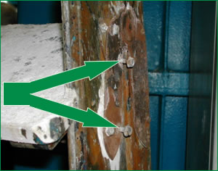
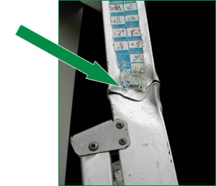
Every year many people are injured whilst using ladders, more than half these accidents occur because ladders are not securely placed and fixed, and of these many happen when the work is of 30 minutes duration or less.

Other causes of ladder accidents include climbing with loads, over-reaching or balancing, using ladders when the user’s footwear has oil, grease or other slippery substance on the rungs. These incidents indicate that ladders are used when other equipment could have been more suitable.

Ladders and stepladders can also be defective and damaged which can also be the cause of accidents. For this reason every time you use a ladder you should carry out a pre-use check to make sure it is safe for use. Ladders should also be subject to a regular formal inspection.

A pre-use check should be carried out by:

- The user;
- At the beginning of the working day; and
- After something has changed i.e. ladder dropped or moved from a dirty to clean area

Ladders

Examples of Pre-Use Checks

- Check the Stiles - do not use the ladder if they are bent or damaged.
Car Doors with broken strengthening straps
- Check the Rungs - do not use the ladder if they are bent, missing or loose.
- Check the Locking Bars - do not use the ladder if they are bent, or the fixings are worn or damaged.
- Check the Steps or Treads - do not use the ladder if they are contaminated, they could be slippery.

- Check the Steps - do not use the ladder if the fixings are loose.
- Check the Stiles - do not use the ladder if they are bent or damaged.

